**M2 - Explain the tools and techniques used in the creation of an interactive website**

**Introduction**

In this report, I will show you the tools and techniques that I have used within my website. The tools and techniques that I will discuss is the following:

* Website Template
* Website Navigation
* Meta tagging
* Cascading Style Sheets (CSS)
* Audio Visual Elements
* Interactive Photo Gallery
* Animation

**Website Template & Website Navigation**

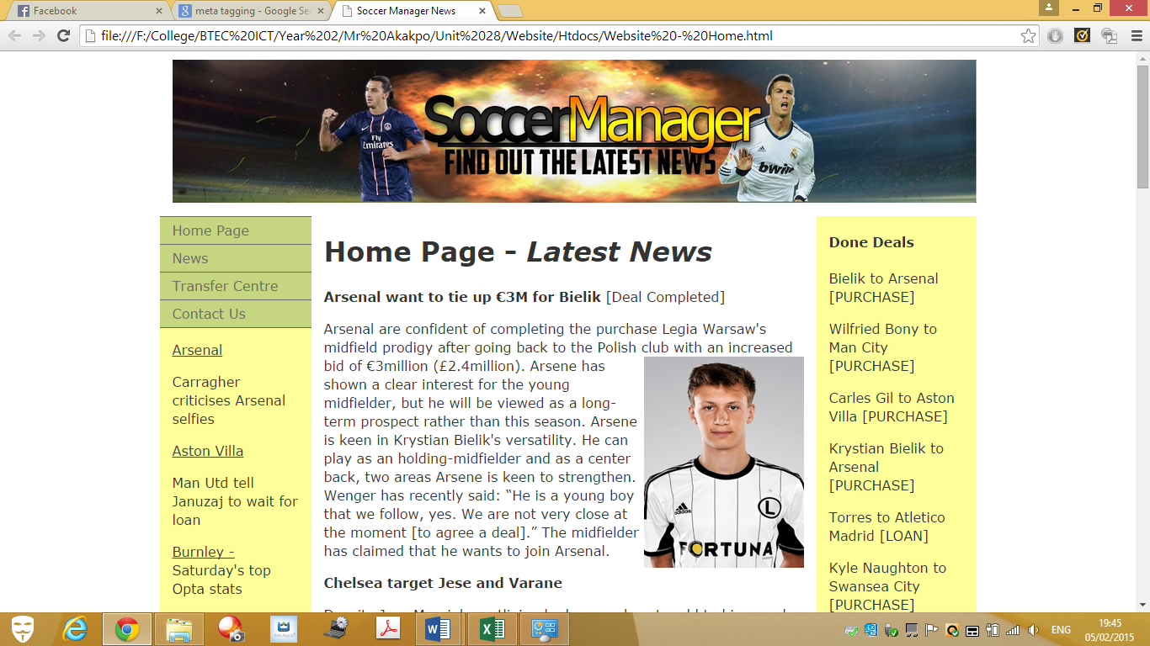

This is my website template. This is used for every page that I have set. The layout for this page is set out similarly. A banner is used within my website to show users what the website is named. As you can see the green box, this shows you the navigation bar. They are all linked together. Therefore, the user can switch pages whenever he/she feels like it. There is three information pages and one contact page. If any trouble with the website, the user can fill in the form to ask what the problem is about.

**Meta Tagging**

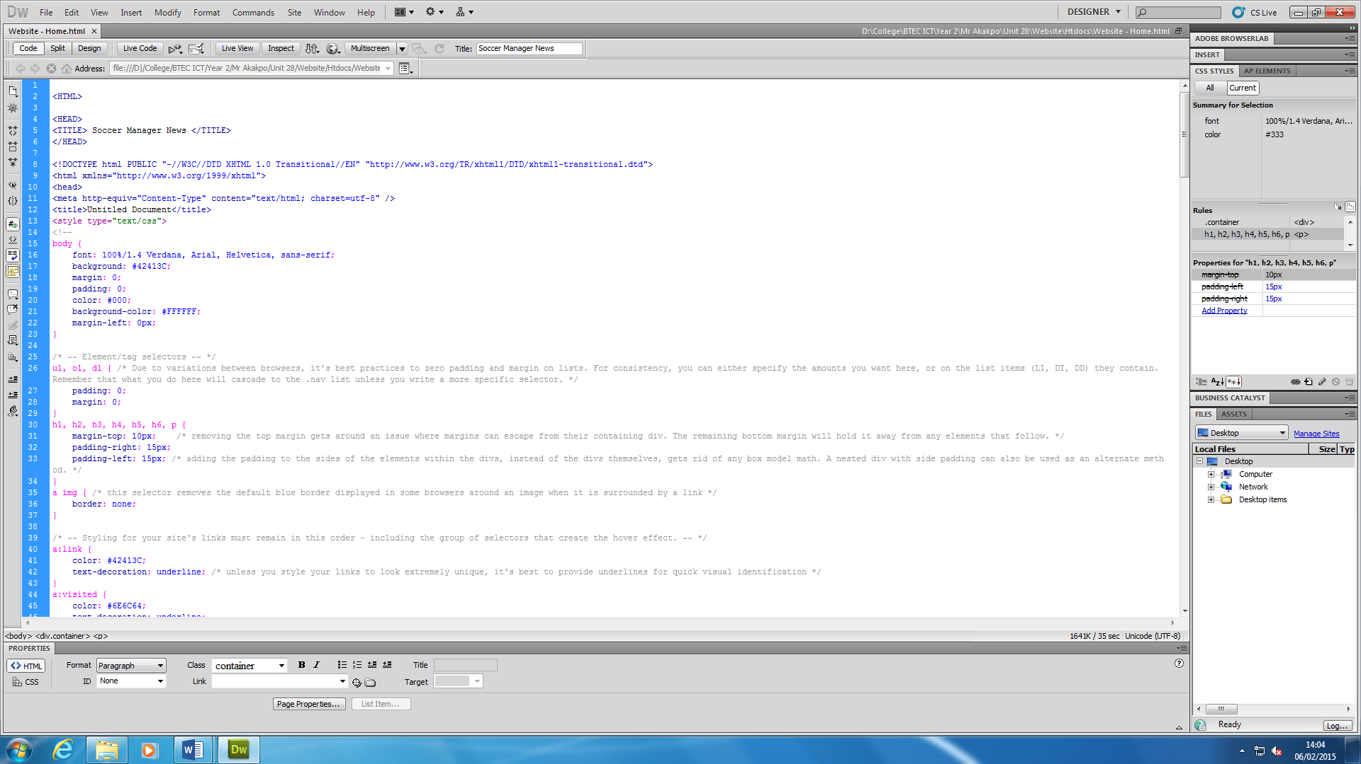

Meta tagging is elements within the HTML document that shows information of what is about the web page, which created the page, and which keywords represent the page’s content. As you can see, there is one meta tag within the HTML document that has been shown above. For example, I could include within my title:

**<meta name = “author”content = “Soccer Manager”. />.**

This shows that the description of the site. This shows the author of who made the website.

**Cascading Style Sheets (CSS)**



This is an example of a CSS sheet. As you can see, it says CSS which proves that it is a casading style sheet. I think this is the important, because it is a new feature thatb shows the details of what you are currently using. Some of the elements that CSS uses is font, colour, layout and font. This enables web developers to have more control of the web page. And, this is applied to any web page. The screenshot above shows one part of the CSS element.

**Audio Visual Elements**

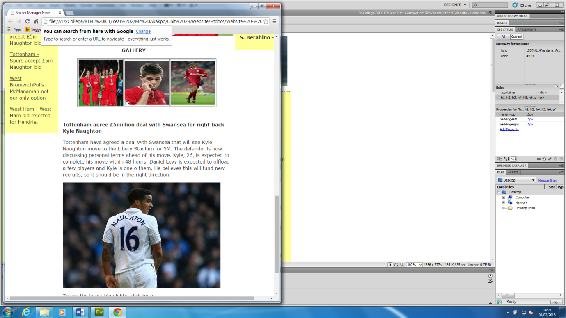Both of these images shows audio and visual elements that have been inserted within my web page.

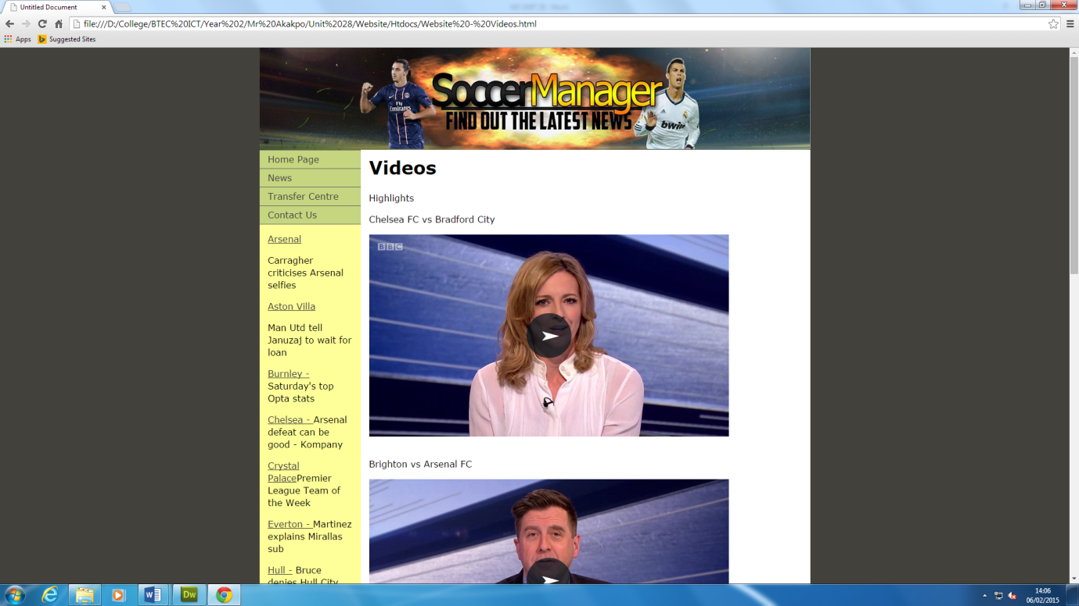

Audio

Visual

**Animation**

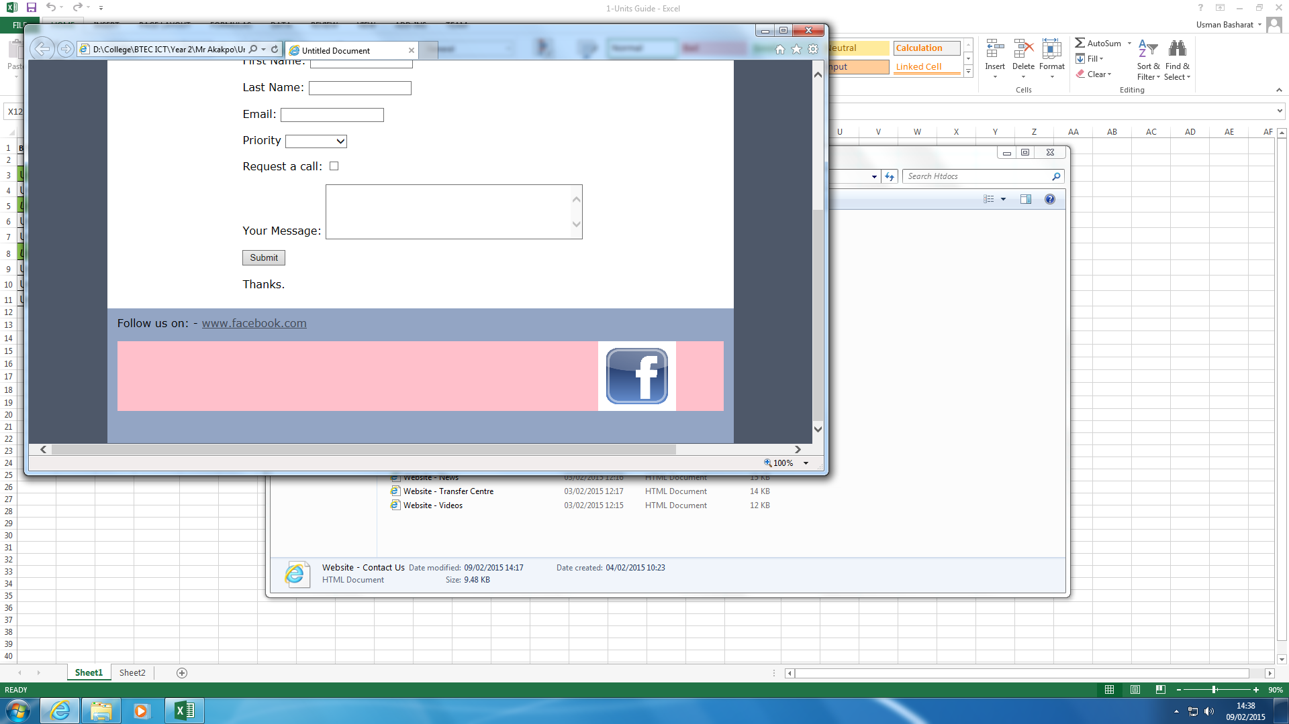

This animation moves from left to right repeatedly. I have included this animation within my website. I personally think that it attracts the users, and they would notice it. It promotes the website too. One of the improvements that I could make is change the colour to the background colour.

**Interactive Photo Gallery**

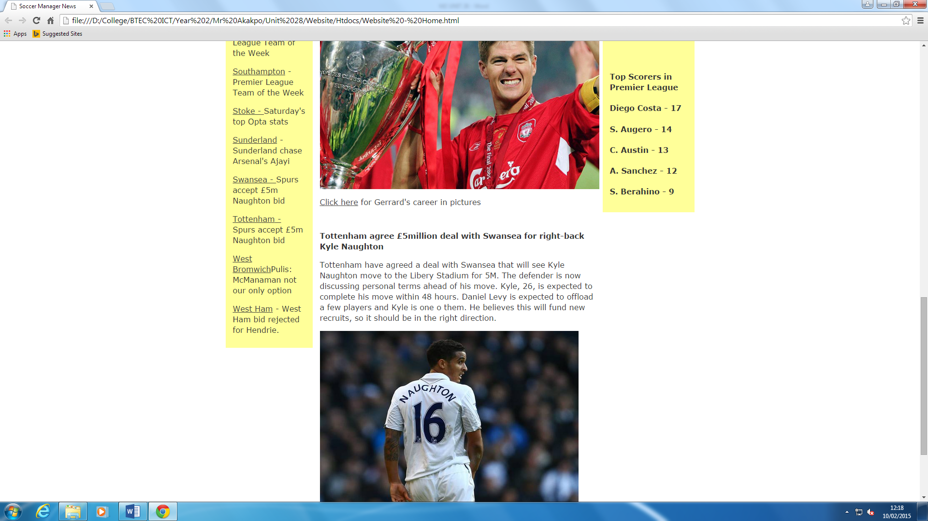

This is the interactive photo gallery. The user has to realise that he/she needs to click on the link for the user to see the gallery.

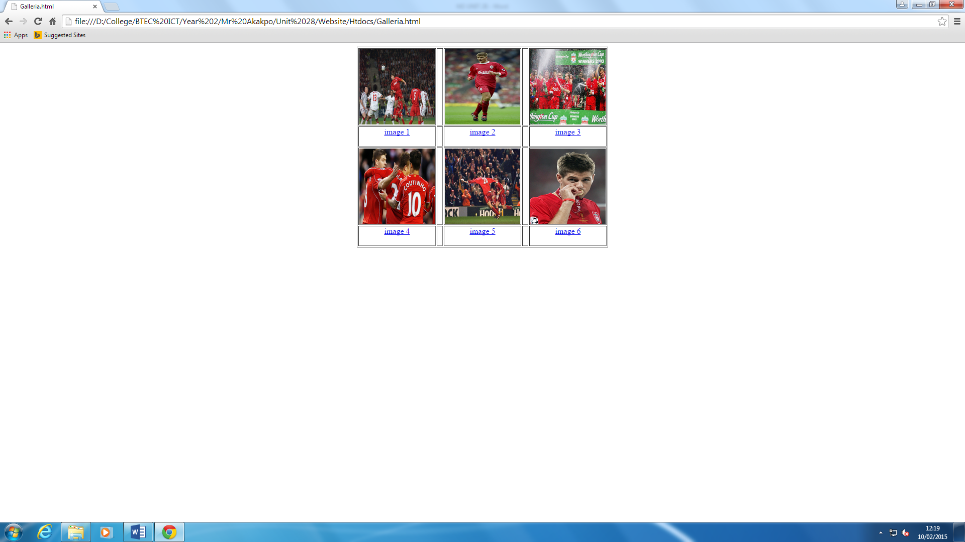

For the user to realise how to get to the gallery. The user should click on ‘image 1’ and he can view the picture below.

The user can go next and previous once he/she is complete.

